|  |
| --- |
| Circle Language Spec: Commands |

## Command References in a Command Reference in a Diagram

This article demonstrates a situation of command objects.

This article illustrates how command references in a command reference look in a diagram.

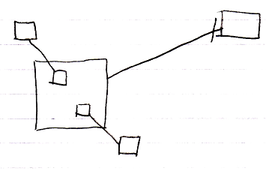

The larger square on the left is a command reference. The target of the command reference is the square on the right, a command definition. The larger square on the left, contains again two command references, smaller squares, that are connected to their reference targets on the outside of the larger command reference.

Most of the squares could have been replaced by diamond shapes, making the command symbol executable, rather than dormant. But the smaller squares inside the larger square can not be replaced by diamonds, because a command can not contain active command references, for reasons explained by the article *Parent Controls Its Sub-Executions*.